1. A multinational recruitment company receives thousands of resumes every day in text format. The HR department requires an automated system to extract candidate information for shortlisting.
Design and implement a Python-based resume information extraction system using Regular Expressions that performs the following tasks:

Extract the candidate's name.
Identify email addresses.
Extract mobile numbers.
Detect technical skills (Python, Java, SQL, Machine Learning, NLP).
Extract years of experience.
Generate a structured summary of the candidate's profile.
Display candidates who satisfy the minimum eligibility criteria (minimum 2 years of experience and Python skill).

Code
import re resume = """
Name: Rahul Kumar
Email: rahul.kumar@gmail.com
Mobile: 9876543210
Skills: Python, Java, SQL, Machine Learning, NLP
Experience: 3 years
""" name = re.search(r"Name:\s*([A-Za-z ]+)", resume) email = re.search(r"[\w.-]+@[\w.-]+\.\w+", resume) mobile = re.search(r"\b[6-9]\d{9}\b", resume) experience = re.search(r"Experience:\s*(\d+)\s*years?", resume, re.I) skills_list = ["Python", "Java", "SQL", "Machine Learning", "NLP"] skills_found = []
for skill in skills_list: if re.search(r"\b" + re.escape(skill) + r"\b", resume, re.I):
skills_found.append(skill) print("----- CANDIDATE PROFILE -----") print("Name:", name.group(1) if name else "Not Found") print("Email:", email.group() if email else "Not Found") print("Mobile:", mobile.group() if mobile else "Not Found") print("Technical Skills:", ", ".join(skills_found)) years = int(experience.group(1)) if experience else 0 print("Experience:", years, "years") if years >= 2 and "Python" in skills_found:
status = "Eligible" else:
status = "Not Eligible" print("Eligibility:", status)

Output
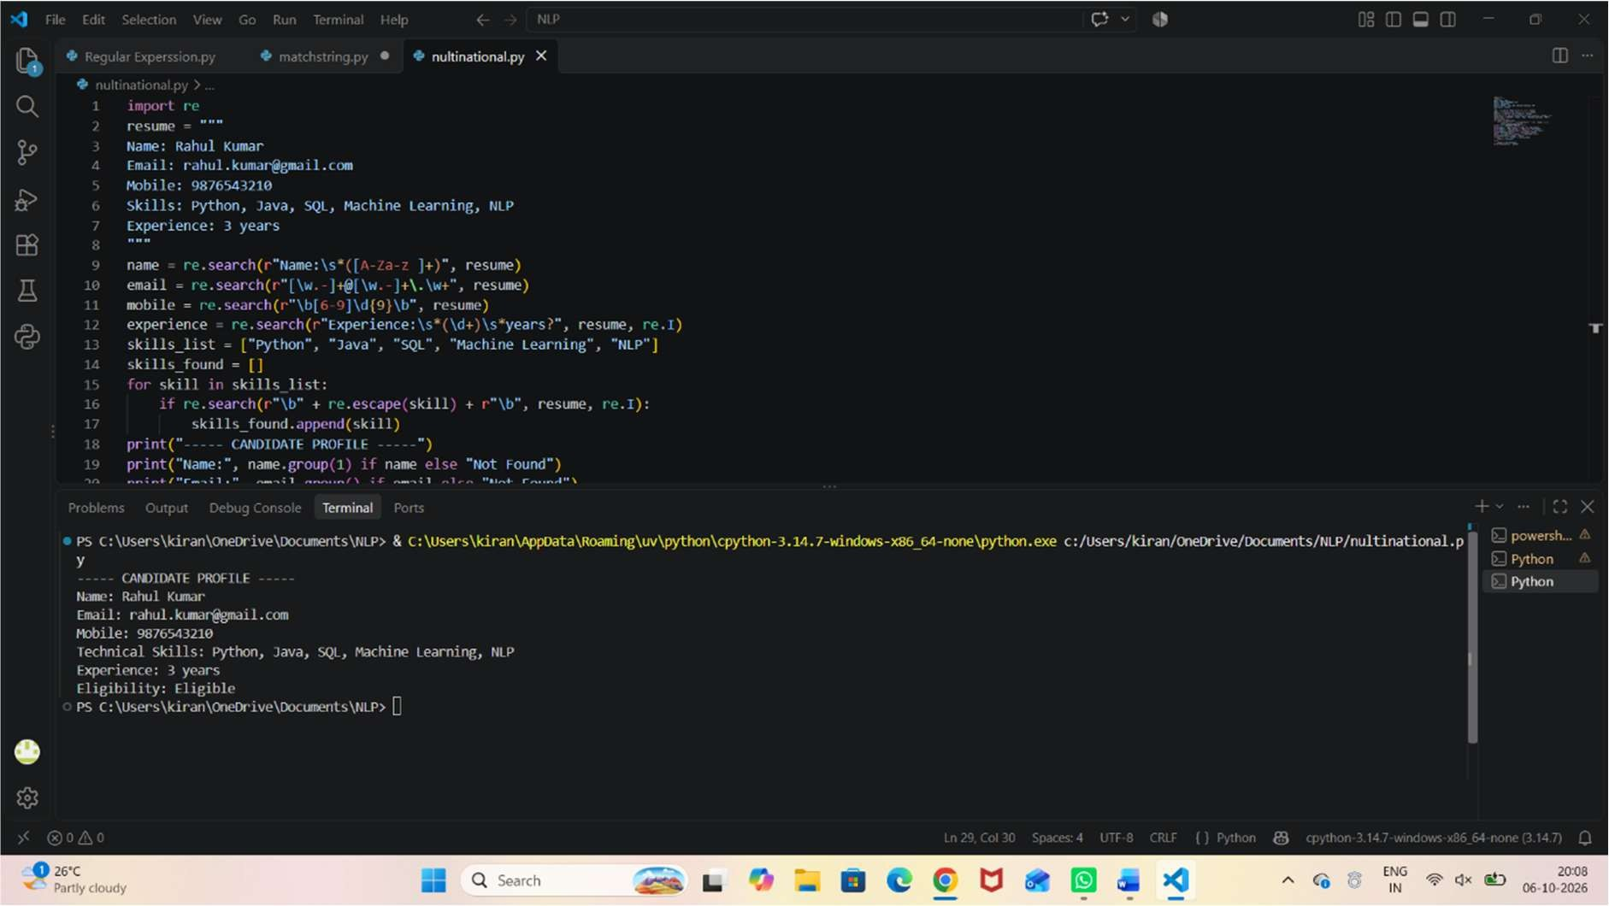

2.An e-commerce company plans to enhance its product search engine to improve customer experience through flexible keyword matching.

Design and implement a Python-based product search system using Regular Expressions that performs the following tasks:

Search products using an exact keyword.
Perform prefix-based searches.
Perform suffix-based searches. Search using partial keywords.
Perform case-insensitive searches.
Display all matching product names.
Generate a report showing the total number of matching products for each search

Code
import re products = [
"Python Programming Book",
"Java Programming Book",
"Python Laptop",
"Java Laptop",
"Machine Learning Course",
"SQL Database Guide",
"Python Course",
"NLP Tutorial"
]
def search_products(keyword, search_type):
if search_type == "exact":
pattern = r"\b" + re.escape(keyword) + r"\b" elif search_type == "prefix":
pattern = r"\b" + re.escape(keyword) elif search_type == "suffix":
pattern = re.escape(keyword) + r"\b" elif search_type == "partial": pattern = re.escape(keyword)
else:
print("Invalid search type") return matches = [] for product in products: if re.search(pattern, product, re.IGNORECASE):
matches.append(product) print("\nSearch Keyword:", keyword) print("Search Type:", search_type) if matches:
print("Matching Products:") for product in matches: print("-", product) else:
print("No matching products found.") print("Total Matching Products:", len(matches)) search_products("Python", "exact") search_products("Python", "prefix") search_products("Book", "suffix") search_products("Prog", "partial") search_products("python", "partial")

Output

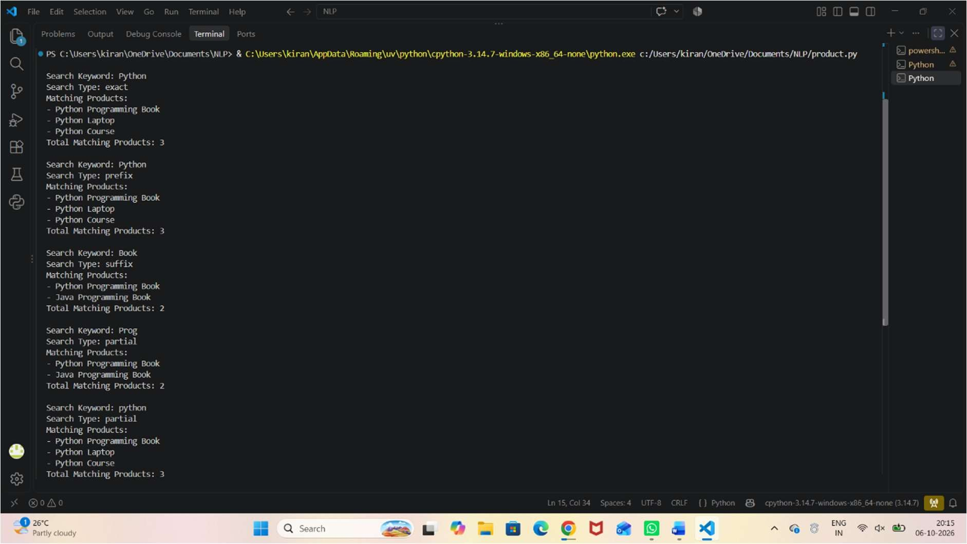

3.A university is developing an automated online registration portal to verify student information before course enrollment.

Design and implement a Python-based validation system using Regular Expressions that performs the following tasks:

Validate the student register number.
Validate the institutional email address.
Validate the course code.
Validate the semester information.
Validate the student's mobile number.
Display appropriate validation messages for each field.
Generate a final registration status report indicating whether the registration is successful

Code
import re

register_no = input("Enter Register Number: ") email = input("Enter Institutional Email: ") course_code = input("Enter Course Code: ") semester = input("Enter Semester: ") mobile = input("Enter Mobile Number: ") register_pattern = r"^\d{9}$" email_pattern = r"^\d{9}\.simats@saveetha\.com$" course_pattern = r"^[A-Z]{3}\d{4}$" semester_pattern = r"^[1-8]$" mobile_pattern = r"^[1-9]\d{9}$" register_valid = re.match(register_pattern, register_no) email_valid = re.match(email_pattern, email) course_valid = re.match(course_pattern, course_code) semester_valid = re.match(semester_pattern, semester) mobile_valid = re.match(mobile_pattern, mobile) print("\n----- VALIDATION RESULTS -----")
if register_valid:
print("Register Number: Valid") else:
print("Register Number: Invalid") if email_valid:
print("Institutional Email: Valid") else:
print("Institutional Email: Invalid") if course_valid:
print("Course Code: Valid")
else:
print("Course Code: Invalid") if semester_valid:
print("Semester: Valid") else:
print("Semester: Invalid") if mobile_valid:
print("Mobile Number: Valid") else:
print("Mobile Number: Invalid")
if register_valid and email_valid and course_valid and semester_valid and mobile_valid:
print("\nRegistration Status: SUCCESSFUL")
else:
print("\nRegistration Status: FAILED")

Output

